# 

# Restaurant System

Software Engineering SE3037 Project

PREPARED BY:

Razan Abdullah Al-Khalidi – 4441043

Sara Alqozi—444008237

Rola Alnashri— 44412063

Retaj Hasan Al-Zbydi —444002396

Arwa Mohammed Alkayri— 444007520

PHASE: 1



1.1 INTRODUCTION:

The increasing demand for mobile applications is a widespread phenomenon in the present time. This is attributed to the availability of advanced technology and the proliferation of smartphones and tablets, enabling people to access a wide range of different applications on their mobile devices.

A restaurant application is a good idea to respond to this growing demand. The application can provide clients with a modern and convenient experience for clients .

1.2 PROJECT DESCRIPTION AND PURPOSE:

. The restaurant application is designed to facilitate and enhance the client experience while ordering food, as well as enable electronic payment. The application provides a user-friendly interface and a range of features that streamline the ordering process and provide convenience for clients. It also promotes communication between clients and offers personalized and customized experiences.

1.3 Problem:

Clients are facing difficulty in easily finding available restaurants and options that are suitable for them. Many people rely on these applications to order food and enjoy the dining experience at restaurants, homes, or public places. The application should be capable of handling a large volume of clients and orders. It should be designed to be scalable and efficient in terms of performance. It should also provide secure and reliable payment mechanisms for clients.

1.4 STAKEHOLDERS:

Restaurant Owners:

They benefit from expanding their business reach and increasing access to clients, as well as improving order management and delivery processes.

Software Development Companies:

They contribute to the development and maintenance of the application, improving its performance and flexibility.

Financial Service Providers:

They offer services for managing employee salaries and provide secure payment services.

Employees:

These are the individuals directly involved in operating the application and managing the operations. Improving the employee experience is important for increasing work efficiency and job satisfaction.

Users:

They seek a convenient and easy food ordering experience through the application, including selecting restaurants, choosing menus, and tracking orders.

Delivery Drivers:

These are the couriers who are available to deliver orders from the restaurant to clients addresses.

1.5 User and System Requirements

|  |  |
| --- | --- |
| **User Requirements** | **System Requirements** |
| 1. The System shall allow the clients to Register and manage their profiles. | * 1. The client shall register to the system with the username and password (The password should consist of more than 8 Number and Letters, Capital Letters are not allowed).   2. The Username should be only in English, and it consists of letters and numbers.   3. The System shall allow the client to manage his file, change the name, password and contact number or even delete. |
| 1. The System shall include the ability to search where the client can find the desired food. | * 1. The System shall provide searching for food to define whether this food is available or not, if not the system shall appear to client “This type of food is not available”.   2. The System shall allow searching by image or text for the type of food required. |
| 1. The System shall support multiple language. | * 1. The System shall support more than on language such as Arabic, English, Chinese and others.   2. The System shall allow the client to choose the appropriate language for him through a button on the personal profile. |
| 1. The System shall be available for download through the mobile application store. | * 1. ‏The system shall be available for different operating systems for the phone, such as Android iOS and other systems.   2. The system shall be available for free download without fees or financial restrictions. |
| 1. ‏The system should support notifications and alerts for clients. | * 1. ‏There should be a system for sending immediate notifications to clients via email or mobile phone messages to confirm orders and update their status.   2. ‏Alerts should be provided to clients when special offers or discounts on meals that may interest them become available. |

|  |  |
| --- | --- |
| **User Requirements** | **System Requirements** |
| 1. ‏The system should provide delivery options that suit client’s locations. | * 1. ‏Diverse delivery options should be provided to meet client’s needs, such as home or office delivery, delivery to specific branches, or self-pickup from the restaurant. |
| 1. ‏The system should offer client support for client to respond to their inquiries and assist them. | * 1. ‏A client support system should be provided that allows clients to communicate with the support team, ask questions, and share their problems via phone, email, or live chat.   2. ‏Quick response times and effective solutions to client problems and specific needs should be provided. |
| 1. ‏The system should allow for advanced order options to meet specific client needs. | * 1. ‏Advanced order options should be provided to meet specific client needs, such as pre-ordering meals outside of regular business hours or placing group orders for several people at the same time. |

1.6 FUNCTIONAL REQUIREMENTS

|  |  |
| --- | --- |
| ID | 1 |
| Title | Food Ordering |
| Description | Clients should be able to select the items they want to order from the menu, including options to customize (e.g., add or remove ingredients). |

|  |  |
| --- | --- |
| ID | 2 |
| Title | Order Tracking |
| Description | Clients should have the ability to track the status of their orders, starting from order confirmation to delivery |

|  |  |
| --- | --- |
| ID | 3 |
| Title | Order Rating |
| Description | Clients should be able to provide ratings and reviews for their orders to help others in making food choices. |

|  |  |
| --- | --- |
| ID | 4 |
| Title | Electronic Payment Methods |
| Description | Clients should have easy and secure electronic payment options, such as credit cards and digital wallets. |

|  |  |
| --- | --- |
| ID | 5 |
| Title | Clients Support |
| Description | An efficient client support system should be provided, including options for phone, email, or live chat, to assist clients with any issues or queries they may |

1.7 Non-Functional Requirements

|  |  |
| --- | --- |
| ID | 1 |
| Title | Security and protection |
| Description | Mechanisms such as data encryption, secure communications, authentication, and identity verification should be provided. |

|  |  |
| --- | --- |
| ID | 2 |
| Title | Client data storage |
| Description | Client data should be stored securely and protected. This includes personal information such as name, phone number, email address, and payment methods used. |

|  |  |
| --- | --- |
| 3 | ID |
| Upgradeability and maintainability | Title |
| The restaurant system should be upgradeable to accommodate new features, improvements, and security fixes. | Description |

# 

|  |  |
| --- | --- |
| 4 | ID |
| Performances and responsiveness | Title |
| The application should be responsive and capable of handling a large volume of orders and users in a timely manner. | Description |

|  |  |
| --- | --- |
| 5 | ID |
| Multilingual support | Title |
| The application should be available in multiple languages, allowing clients from different cultures and languages to better understand and use the application. | Description |

PHASE:2

2.1 INTRODUCES:

This stage involves creating diagrams of the core elements and illustrating how they are represented, providing a comprehensive overview of the various interconnected components that make up the restaurant application.

2.2 SYSTEM DIAGRAMS:

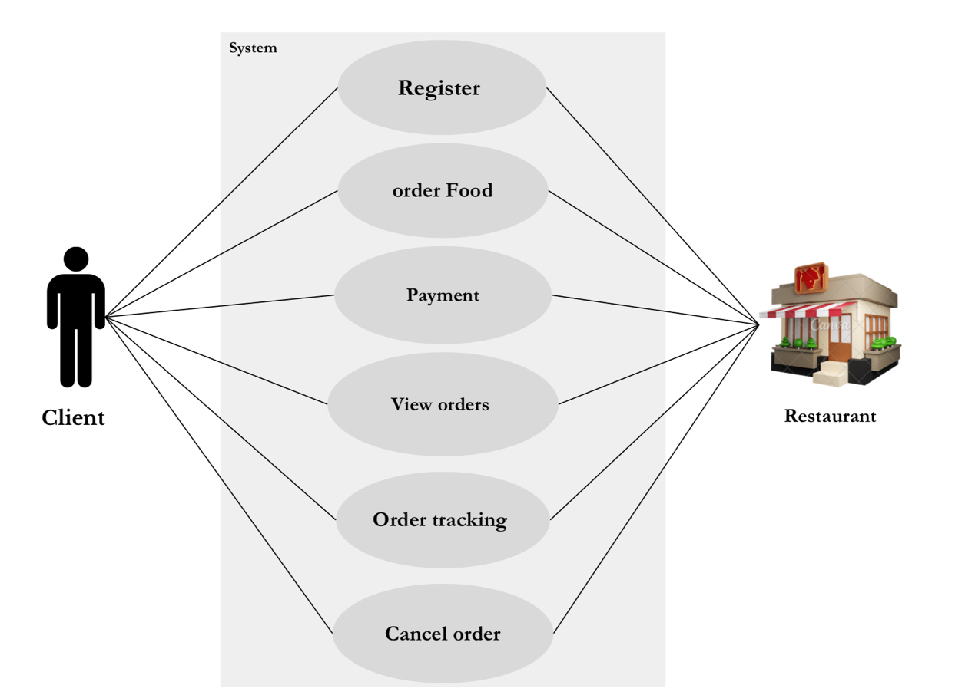2.2.1 Use cases

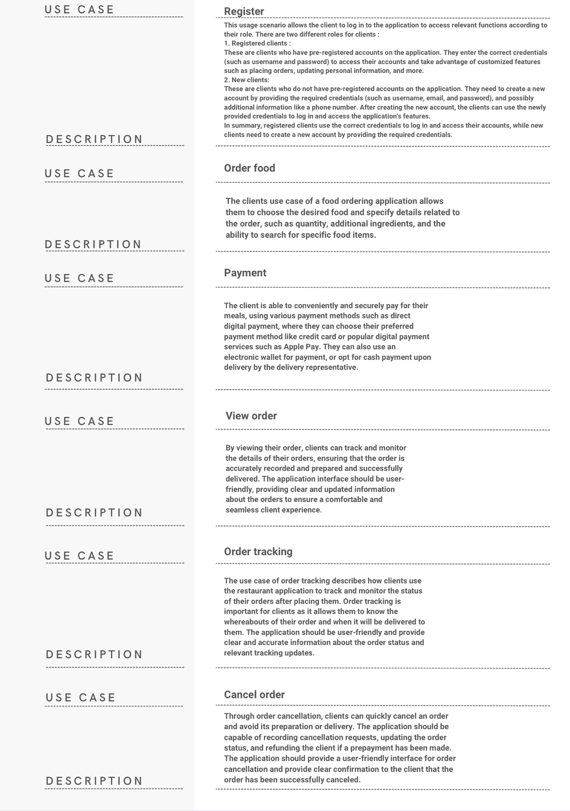

2.2.3Activity diagram

Here is a simplified presentation of the user interactions with the system in a sequential manner, including ordering food and canceling the order:

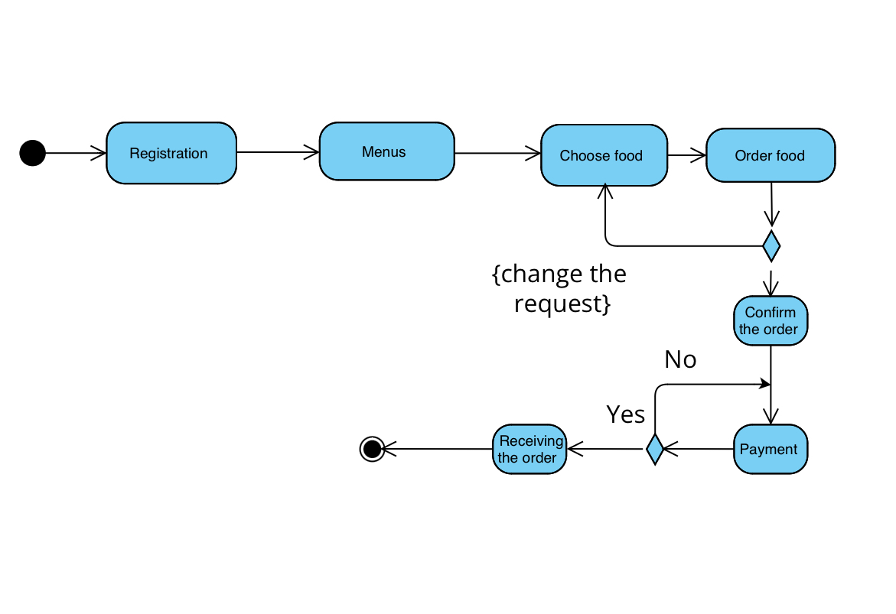

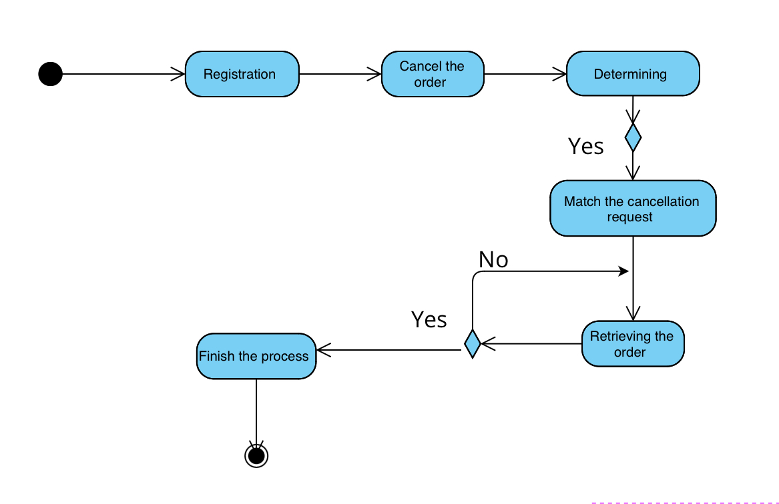

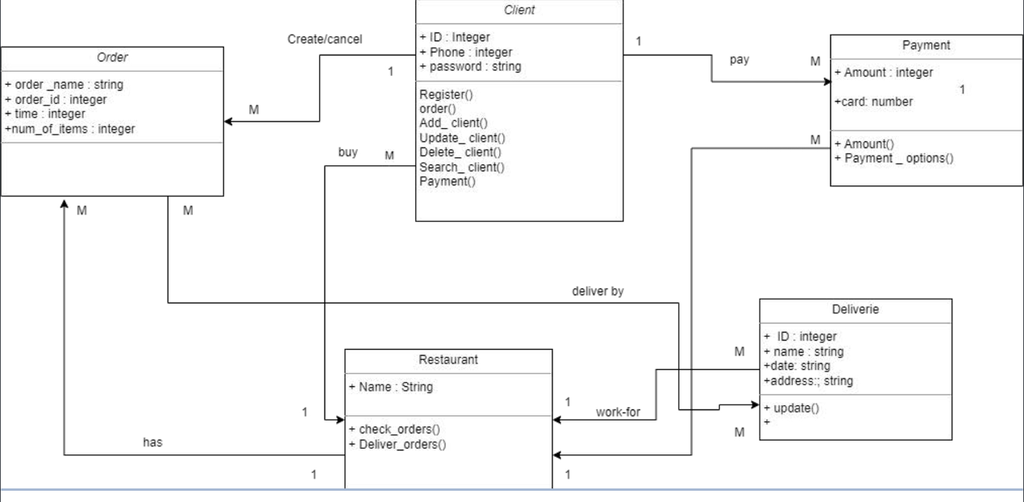2.2.4 class diagram

A Class Diagram is the organization and representation of the structure of classes and how they interact and collaborate with each other. A Class Diagram for a restaurant includes a set of classes that reflect the components of the application and the relationships between them

2.2.5 Sequence diagram

Register \

The client enters the registration data on the registration page, and the data is sent to the admin for verification. Then the verification result appears if the data is valid. A new client is added, and the client is redirected to the home page.

If the data is invalid, an error message appears to the client.

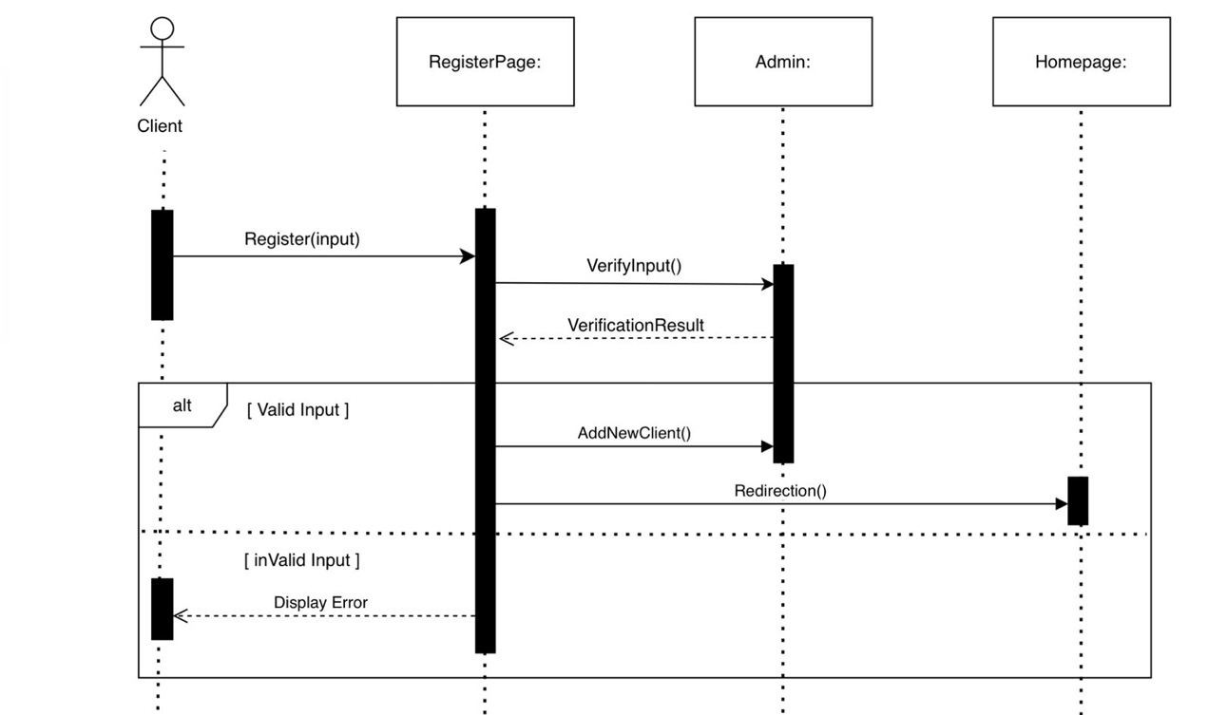

Order food \

The client displays the menu, which is processed by the menu database. The menu is shown to the client, then he chooses the desired food, and then the restaurant system verifies whether the order is complete or not.

If it is complete, the application is accepted

If it is not complete, the client is asked to complete it by choosing another meal.

Then processing is done

Delivery data is sent to the client

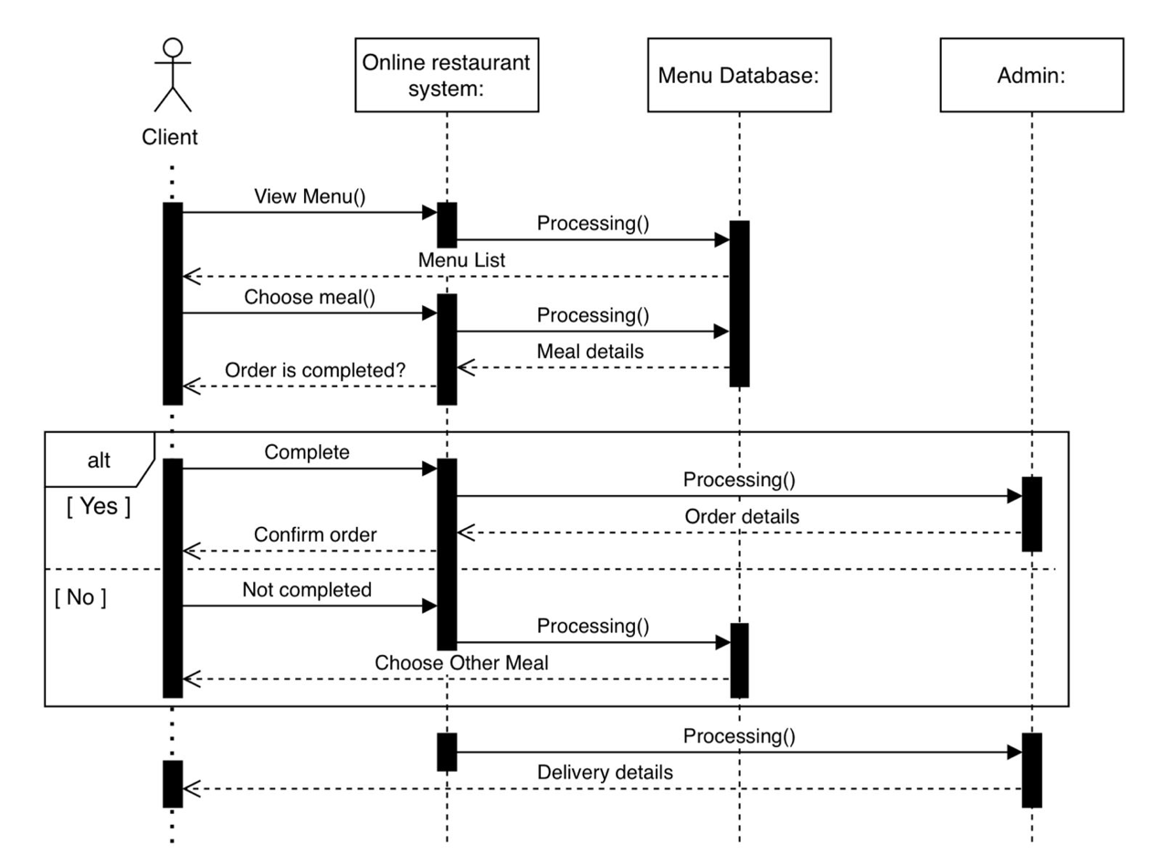

Payment process \

After the client selects his request, he presses the payment button and processing is completed. Then the client has the choice between paying by card or cash

If it is by card, payment is made, then processed, and a “payment is done” message appears to the client. Then the restaurant contacts the delivery man to deliver the order to the client.

If the payment is cash

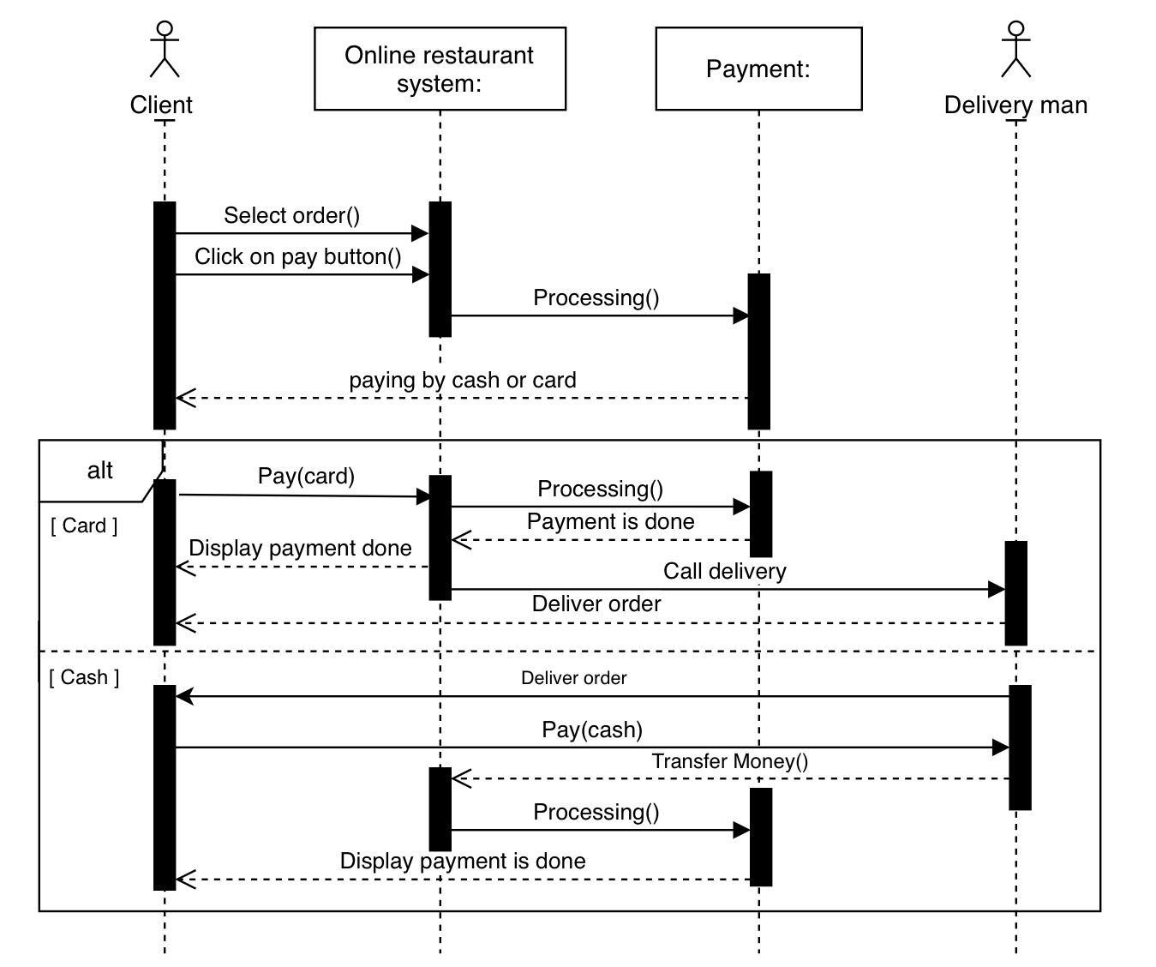The order will be delivered, then the client will pay the delivery man. The delivery man will transfer the money to the restaurant’s system, and then a “payment is done” message will appear to the client

View order\

The client selects items and confirms the order. A summary of the order is displayed to the client, and they confirm the order. The restaurant creates the order and updates its status. The order is delivered, and the updated status is displayed to the client.

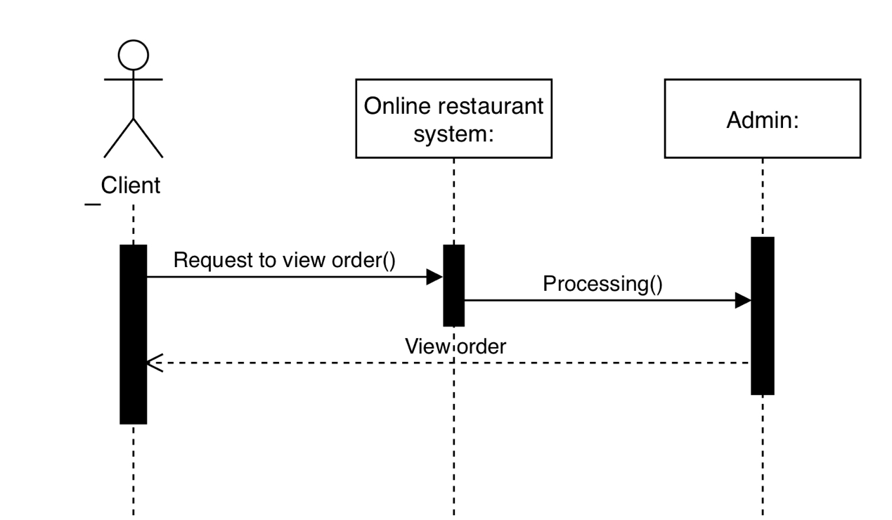

view tracking\

The client selects items and confirms the order. The restaurant creates and prepares the order, then delivers it to the client.

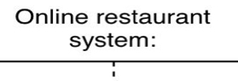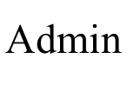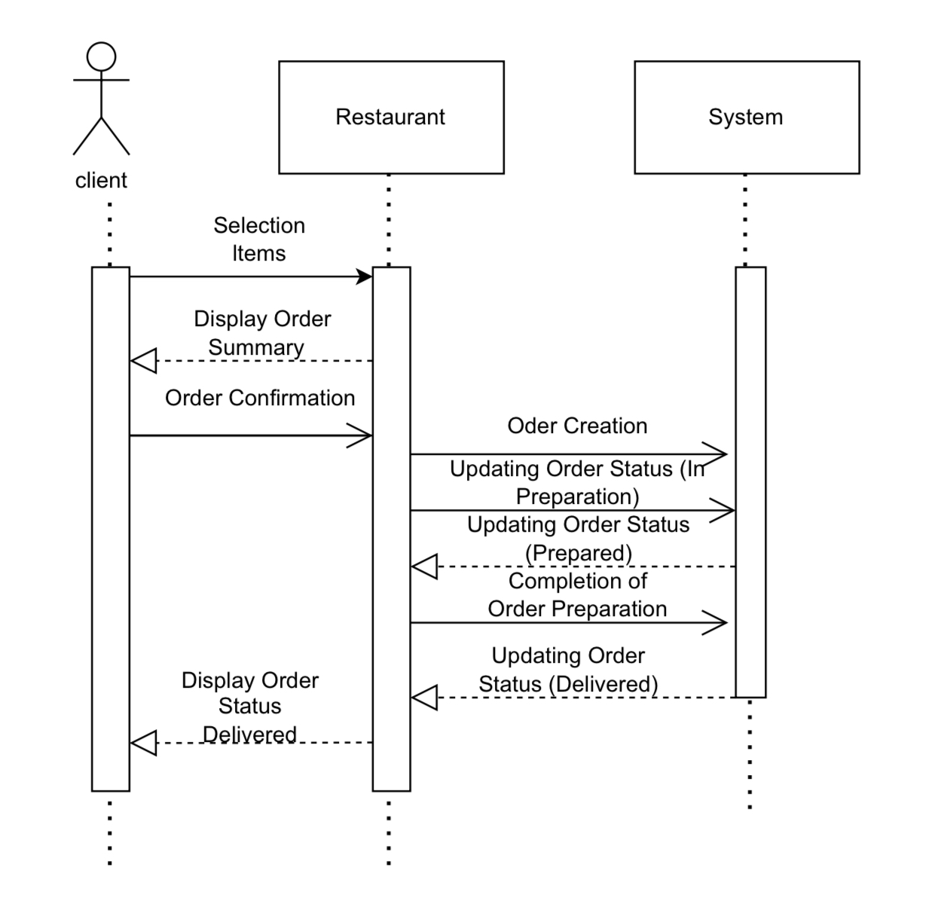



Cancel order **\**

The client sends a request to cancel the order to the restaurant. The request is transferred to the restaurant's system. The system cancels the order and updates its status. A cancellation confirmation is sent to the client .

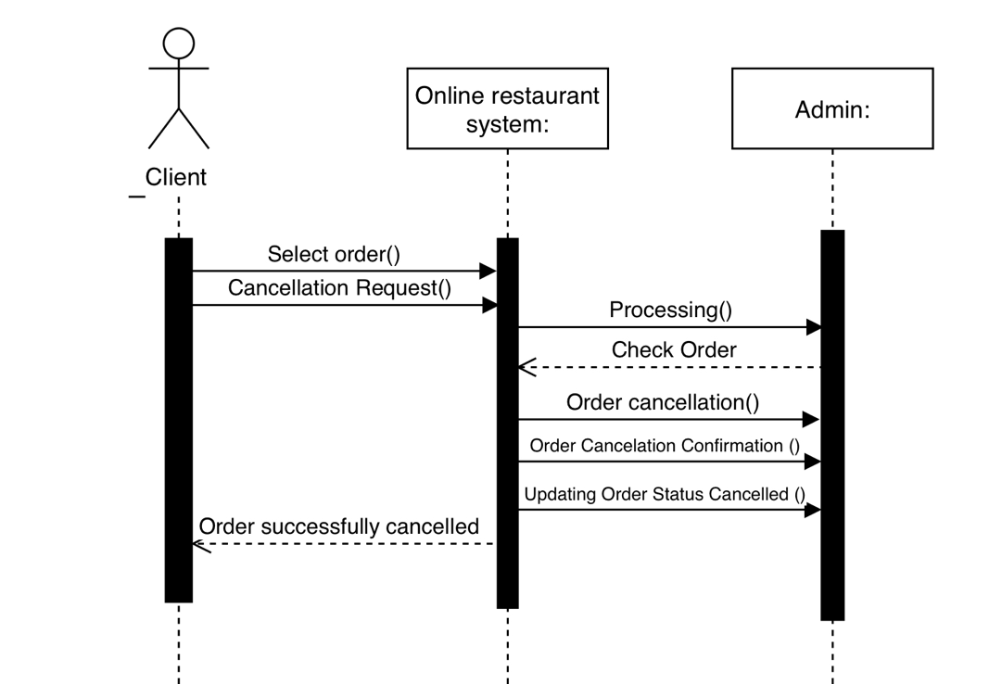

**:Conclusion**

Available restaurants easily and suitable options for customers.

- The application should be able to handle a large volume of customers and orders and be capable of scalability and efficient performance.

- Stakeholders in the project include restaurant owners, software development companies, financial service providers, employees, users, and delivery drivers.

- There are multiple requirements for both the user and the system, including user registration, food search, support for multiple languages, app availability for download, customer notifications and alerts, diverse delivery options, customer support, and advanced ordering options.

- There are functional requirements that include food ordering, order tracking, order rating, and electronic payment methods.

- There are non-functional requirements that include security and protection, customer data storage, upgradeability and maintenance, performance and responsiveness, and support for multiple languages.

- UML models such as use case diagrams and activity diagrams and class diagram and sequence diagram can be used to illustrate the details and sequence of operations in the application.